Keeping your Birdie Healthy
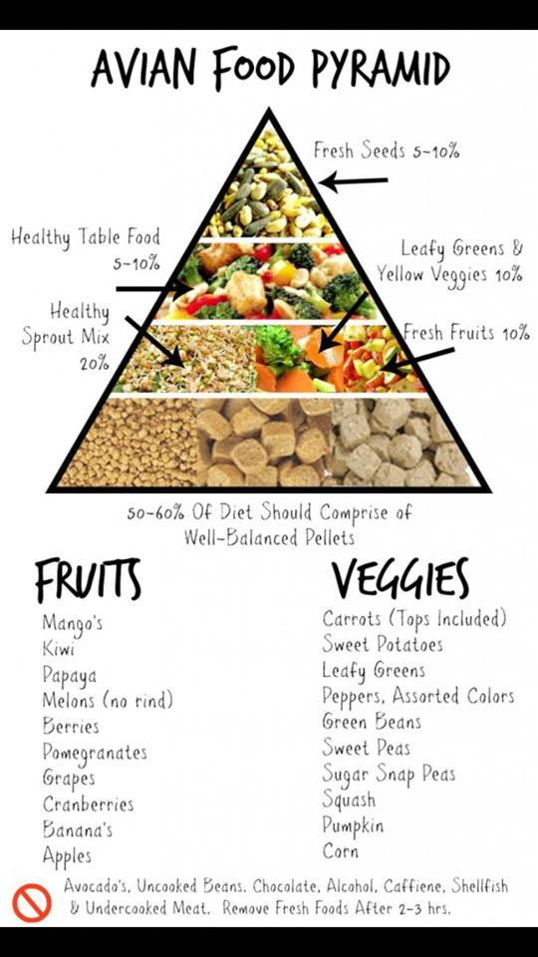
I feed my birds their Mash / Veggies first thing in the morning. Providing the humidity is not to high or to warm, you can leave this in their cage for 2-6 hours. If birdie is not eating his mash try sprinkling some millet on top to entice him.
I add fresh or thawed fresh veggies to the mash or sometimes to the side. This way it is almost always different and birdie does not get bored with his meals.

WHY SPICES:
For Flavor and for their health benefits. In my mash I always put the following spices. AND YES I have actually tasted the mash to see if it balances/ tastes ok.
Fenugreek, Oregano (sometimes), Parsley, Dill, Cilantro, Cumin seeds, Cardamin seeds, Mint, Cayanne Pepper, Chilli Pepper, Paprika, Cinnamon, Tumeric (Always)
If you have the Dill, Parsley, Cilantro fresh you can add that as a fresh veggie.
I usually cook up rice/bulger/lentils and such and while still hot will put in the spices I'm using to help the oils from the powders release because of the heat of the rice etc....it coats each grain and when mixed later with the FRESH LIVE FOODS also gets onto those.

Turmeric.
This common spice helps regenerate liver cells and cleanses the liver of toxins. Turmeric increases the production of bile and is a potent anti-inflammatory. Turmeric increases levels of two liver-supporting enzymes: glutathione-s-transferase (GST) and UDP glucuronyl transferase (UDPGT).This info is taken from: HolisticBird and HolisticBirds
It's an article on Fatty liver Disease and what you can do to help your birds who have it/ and to keep them from getting it....
Tumeric is also a good digestive aid.Tumeric also acts like an anti-coagulant, so I would avoid using it when a bird is molting, or has a problem with broken blood feathers. (This is why I always say use this spice SPARINLY but use it they love the flavor).
It has excellent anti-inflamatory properties, and is a good supplement when a bird has pain such as from gout.
It is a great antioxident and can act as a natual source of presservative in foods like birdy breads. Tbe antioxidants also reduce free radicals in the body.
It also helps to alleviate nausea, such as a baby that has crop problems and is vomitting back up food. Ginger is also good for this too.
If tumeric is applied to the skin ..such when there is an injury, in combination with exposure to sunlight or full-spectrum light it can have strong antibacterial properties.
Cinnamon
Cinnamon also aids in digestion. It is high in fiber, Iron, Calcium and Manganese, It can be used as a treatment for fungals and aspergillius. It gives release from arthritis pain. Since it has anti-bacterial properties, it helps lessen the growth of bacteria on fresh food.
Cinnamon sticks make excellent chew toys.

Cayanne Pepper:
Cayenne Pepper is loaded with Vitamins A and C, B-complex. Potassium, Iron and calcium. It increases fat metabolisim and reduced fat deposits-great for birds with or prone to fatty liver disease. It stabilizes bleeding, shock and has been known to stop heart attack. It returns blood pressure to normal and improves circulation.

Paprika:
Paprika has many of the same benefits as cayenne being high in vitamins A , C Iron and calcium. It is ground from a dried sweet red pepper. It has anti-inflamatory and anti-oxidant effects as does cayenne. It is an excellent sources of minerals like copper, potassium, calcium , Iron. Potassium is an importan component of cell and body fluids that control heart rate and blood pressure by countering action of sodium

FenuGreek:

is also rich vitamins that are essential nutrients for optimum health, including thiamin,pyridoxine (vitamin B6), folic acid, riboflavin, niacin, vitamin A, and vitamin-C.
Its seeds have been used in many traditional medicines as a laxative, digestive, and as a remedy for cough and bronchitis.
If used regularly, fenugreeks may help control cholesterol, triglyceride as well as high blood sugar (glycemic) levels in diabetics.
Fenugreek seeds added to cereals and wheat flour (bread) or made into gruel, given to the nursing mothers may increase breast milk production.
Ginger:
Ginger is often used as a preventative for motion sickenss. You might be surprised how many birds suffer from motion sickness. But transporting our birds by car is sometimes necessary. You can offer your bird fresh ginger root or make a tea out of it by steeping fresh ginger slices in hot water.(allow to cool thoroughly before serving)Replace with normal drinking water a couple hours before your trip.
Dill:
Dill is very useful in both settling digestive disorders and has calming properties. It can be offer fresh, dried (added to wet foods) or steeped in a tea
Mint:
Mint is used for a number of digestive discomforts from nausea to indigestion,but it has stimulant properties and it is best that they do not get this before bedtime. The leaves can be served fresh, steeped in a tea. Dilute full strength tea with plain water (1/4 tea with 1 cup of water)

Chamomile:
Chamomile is great for a restless or nervous parrot. If you are traveling or boarding a bird that is uncomfortable in new surroundings or have a bird with night frights. Chamomile tea might help. Offer it warm even in mug just before bed time. Dilute ¼ cup of tea with 1 cup of warm water. Just the act of having a warm cup of tea with your birdie is calming itself.
Sage:
Sage is used for digestive disorders but it is also supportive of the liver and used to boost functioinality ( I have never used sage in my mash)
Coconut Oil:
Coconut oil.. is one of the richest natural plant sources of Beta carotene in the world. Beta Carotene is consumed and then converted to Vitamin A. During digestion process. Coconut oil is also rich in Lauric Acid. It is accepted as an antiviral and Anti-bacterial agent. Lauric acid turns into 2- monolaurin, in the digestive process and offers anti – microbial properties. VIRGIN ORGANIC COCONUT OIL creates an incredible sheen on our birds feathers and makes them healthy and strong. Their feathers develop such beautiful and vibrant colors.

WHAT veggies do I use?
fresh veggies/ Fruits ( or in the mash)
APPLES & POMEGRANATE are my birds FAVORITES
Romaine Lettus (always fresh) Corn
Kale ( can be cut and frozen) Peas
Parlsey Broccolli
Dill Carrots
Cilantro
Sometimes ( raspberries, Blueberries, Blackberries)
Sometimes ( Cucumber,Spinach, Dandilion,Bok choy)
Qunioa I sprout it and add it warm to the dish they prefer it than added in the mash when making it.
Coucous: no one is fussy on this but I make it anyway. I just pour hot water over it let it do its thing. Add veggies/ such as corn, peas, carrots, Broccoli,Kale as an example. Add some spice. They will eat is as they pillage for the veggies.

